

As members of the Kabarak University family, we purpose at all times and in all places to set apart, in one’s heart, Jesus as Lord. (1 Peter 3:15)
Kabarak University
ISO 9001:2015 CERTIFIED

DEPARTMENT OF COMPUTER SCIENCE & INFORMATION TECHNOLOGY

FARM PRODUCE TRANSPORT SHARING SYSTEM
BRIAN MWAURA INTE/M/0854/05/24
ANGELA MWAURA CS/M/0941/05/24
GODWIN KIPKORIR INTE/M/0790/05/24

A Project Proposal submitted in partial fulfillment of the requirements for the award of the
Bachelor of Information Technology of Kabarak University

FEBRUARY, 2026

DECLARATION
I declare that this project proposal is my original work and has not been presented for the award of any degree or any other academic qualification in any institution of higher learning.
Student Name: __________________________
Signature: _____________________________
Date: _________________________________

RECOMMENDATION
This project proposal has been submitted for examination with my approval as the University Supervisor.
Supervisor Name: _______________________
Signature: _____________________________
Date: _________________________________

COPYRIGHT

All rights reserved. No part of this document may be reproduced, stored in a retrieval system, or transmitted in any form without prior written permission from the author or Kabarak University.

ACKNOWLEDGEMENT
I give thanks to Almighty God for the wisdom, strength, and guidance throughout the preparation of this project proposal. I sincerely appreciate my supervisor for the professional guidance and constructive feedback offered during the development of this work. I also extend my gratitude to the lecturers of the Department of Computer Science and Information Technology, my fellow students, friends, and family members for their encouragement and support throughout my academic journey.

DEDICATION
This project is dedicated to small-scale farmers whose resilience and commitment to food production inspire the development of innovative solutions aimed at improving agricultural efficiency and sustainability.

Contents
1
DEPARTMENT OF COMPUTER SCIENCE & INFORMATION TECHNOLOGY 2
FARM PRODUCE TRANSPORT SHARING SYSTEM 2
DECLARATION 2
RECOMMENDATION 3
COPYRIGHT 4
All rights reserved. No part of this document may be reproduced, stored in a retrieval system, or transmitted in any form without prior written permission from the author or Kabarak University. 4
ACKNOWLEDGEMENT 5
DEDICATION 6
ABSTRACT 9
INTRODUCTION 11
1.1 Introduction 11
1.2 Background of the Study 11
1.3 Problem Statement 11
1.4 Objectives 12
1.5 Research Questions 12
1.6 Significance of the Study 12
1.7 Scope and Limitations of the Study 13
1.8 Proposed Modules 13
1. User Management Module 13
Sub-modules: 13
2. Farmer Module 13
Sub-modules: 13
3. Transporter Module 14
Sub-modules: 14
4. Transport Sharing & Matching Module 14
Sub-modules: 14
5. Booking & Scheduling Module 15
Sub-modules: 15
6. Communication Module 15
Sub-modules: 15
7. Payment Module 16
Sub-modules: 16
8. Administration Module 16
Sub-modules: 16
9. Reporting & Analytics Module 17
Sub-modules: 17
CHAPTER TWO 18
LITERATURE REVIEW 18
2.0 Introduction 18
2.1 Overview of Agricultural Transport Challenges in Kenya and East Africa 18
2.2 Transport Sharing and Collaborative Logistics Models 18
2.3 Digital Platforms and Web-Based Agricultural Systems 19
2.4 Transport Matching and Load Optimization Techniques 19
2.5 Booking, Scheduling, and Route Coordination Systems 19
2.6 Communication and Notification Systems in Agricultural Logistics 20
2.7 Digital Payment Systems in Agricultural Transport 20
2.8 Administration, Monitoring, and Reporting Systems 20
2.9 Research Gaps Identified 20
2.10 Chapter Summary 21

ABSTRACT
Small-scale farmers frequently face transportation challenges such as high transport costs, delayed deliveries, underutilized vehicles, and significant post-harvest losses. These constraints reduce farmers’ profitability and limit their access to reliable markets, particularly in rural areas of Kenya and East Africa where poor road infrastructure and inadequate cold chain support exacerbate value loss. This project proposes the development of a Farm Produce Transport Sharing System designed to enable farmers to collaboratively share transportation resources by efficiently matching farmers in need of delivery services with available transport providers. The system aims to optimize vehicle utilization, reduce transport costs, limit post-harvest losses, and improve overall market access for farmers. The proposed solution will leverage modern web-based technologies to support user registration, transport booking, route coordination, and real-time communication between farmers and transporters. The expected outcome is a reliable, efficient, and cost-effective transport-sharing platform that enhances agricultural logistics and contributes to improved livelihoods for small-scale farming communities in Kenya and the East African region.

REFERENCES
- Kirui, K. K., Nasirembe, W. W., L. K., & Indika, J. (2025). Impact of Post-Harvest Technologies on Post-Harvest Losses in Crops in Kenya: A Review. SSR Journal of Arts, Humanities and Social Sciences.
— discusses post-harvest losses among Kenyan crops and technologies that reduce such losses, especially relevant to transport and logistics challenges.
- USAID. (Year). Rural Transport and Agriculture Fact Sheet.
— highlights first-mile transport costs and how poor rural transport in Kenya increases transport expenses for smallholder farmers.
- African Development Bank Group. (Year). Agricultural Logistics Management and Related Infrastructure.
— provides insights on transport costs and challenges faced by smallholder farmers in Kenya and Tanzania due to inadequate transport infrastructure.
- Rural Logistics for Smallholder Farmers to Meet New Agricultural Market Demands (Report).
— case studies describing transport and logistics challenges affecting horticultural value chains of smallholder farmers in Kenya.
- Fresh but fragile: African perishables need a logistics fix. LogUpdate Africa.
— explains how high logistics costs driven by poor infrastructure and delays hinder profitability and competitive market access for Kenyan perishable exports.
- Machuki, H. (2025). Infrastructure Challenges and High Logistics Costs Undermine Kenya’s Horticulture Exports – Floriculture.
— discusses transport bottlenecks, high logistics costs, and infrastructure limitations facing Kenyan farmers that impact produce quality and market access.
- DHL Kenya. (Year). Efficient Logistics: A Game Changer for Kenya’s Agriculture.
— outlines the role of efficient logistics in connecting rural producers to markets and reducing delays that shrink farmer profits.

CHAPTER ONE

INTRODUCTION

1.1 Introduction
This chapter presents the foundation of the study by introducing the background and context of the Farm Produce Transport Sharing System. It outlines the problem faced by small-scale farmers in accessing affordable and reliable transportation for farm produce, particularly in rural and peri-urban areas. The chapter further defines the objectives of the project, the research questions guiding the study, and the significance of the proposed system. Additionally, the scope and limitations of the project are discussed to establish clear boundaries for the study. Overall, this chapter provides a rationale for the project and sets the stage for subsequent chapters by clearly defining the motivation and direction of the research.

1.2 Background of the Study
Agriculture remains a critical sector in many developing economies, serving as a primary source of food, employment, and income for a large portion of the population. Small-scale farmers, who form the backbone of agricultural production, often face logistical challenges when transporting farm produce from farms to markets, collection centers, or processing facilities. In many cases, farmers rely on individual transport arrangements, which are costly, inefficient, and unreliable.
The absence of coordinated transport systems results in underutilized vehicles, delayed deliveries, and increased post-harvest losses due to spoilage of perishable goods. Transport providers, on the other hand, frequently operate without full loads, leading to inefficiencies and higher operational costs. With the increasing penetration of mobile and internet technologies, there is an opportunity to leverage digital platforms to address these challenges through shared transportation models. This project seeks to exploit this opportunity by proposing a transport-sharing system tailored specifically to the needs of farmers and transport providers.

1.3 Problem Statement
Despite the availability of transport vehicles in farming regions, small-scale farmers continue to experience high transportation costs and limited access to reliable transport services. The current transport arrangements are largely informal and uncoordinated, leading to inefficiencies such as partially loaded vehicles, delayed pickups, and missed market opportunities. These challenges contribute to increased post-harvest losses and reduced profitability for farmers. Additionally, transport providers lack a centralized platform to connect with farmers who require their services, resulting in lost business opportunities. There is therefore a need for a centralized, technology-driven solution that facilitates efficient coordination between farmers and transport providers to improve the transportation of farm produce.

1.4 Objectives

1.4.1 Main Objective
The main objective of this project is to design and develop a Farm Produce Transport Sharing System that enables farmers to collaboratively access affordable and efficient transportation services for farm produce.

1.4.2 Specific Objectives
i. To investigate the challenges faced by small-scale farmers in transporting farm produce using existing transport arrangements.
ii. To design a transport-sharing system that efficiently matches farmers with available transport providers.
iii. To develop a web-based platform that facilitates booking, coordination, and communication between farmers and transport providers.
iv. To test and evaluate the effectiveness of the proposed system in reducing transport costs and improving delivery efficiency.

1.5 Research Questions
i. What challenges do small-scale farmers face in the transportation of farm produce?
ii. How can a transport-sharing system improve coordination between farmers and transport providers?
iii. To what extent does the proposed system reduce transportation costs and delivery delays?

1.6 Significance of the Study
The proposed system is significant as it aims to improve agricultural logistics by reducing transportation costs and post-harvest losses among small-scale farmers. Farmers will benefit from affordable and reliable access to transport services, while transport providers will gain increased utilization of their vehicles and access to a broader customer base. The study also contributes academically by providing insights into the application of shared-economy models in agricultural logistics. Furthermore, the project may serve as a reference for future researchers and system developers interested in agricultural technology solutions.

1.7 Scope and Limitations of the Study
The scope of this project is limited to the design and development of a web-based Farm Produce Transport Sharing System that facilitates coordination between farmers and transport providers. The system will focus on core functionalities such as user registration, transport booking, route coordination, and communication. The study will be conducted within a defined timeframe and may be limited by factors such as internet accessibility, availability of real users for testing, and resource constraints. Advanced features such as mobile app integration and real-time GPS tracking are beyond the scope of this project.

1.8 Proposed Modules
The proposed system will consist of the following modules:

1. User Management Module
Handles all users of the system (farmers, transporters, and administrators).

Sub-modules:
- User Registration
  - Farmer registration
  - Transporter registration
- User Authentication
  - Login
  - Logout
  - Password recovery/reset
- Profile Management
  - Update personal details
  - Upload verification documents (ID, license)
- Role Management
  - Farmer role assignment
  - Transporter role assignment
  - Admin role privileges

2. Farmer Module
Manages farmer-related activities within the system.

Sub-modules:
- Produce Listing
  - Add produce details (type, quantity, location)
  - Update or delete produce listings
- Transport Request
  - Create transport request
  - Specify pickup and delivery locations
  - Select preferred transport time
- Request Tracking
  - View request status (pending, accepted, completed)
- Cost Estimation
  - View estimated transport cost
- Communication
  - Chat with transporter
  - Receive notifications

3. Transporter Module
Manages transport provider operations.

Sub-modules:
- Vehicle Management
  - Register vehicle details
  - Update vehicle availability
  - Vehicle capacity management
- Route Management
  - View available transport requests
  - Select optimal routes
- Request Handling
  - Accept transport requests
  - Reject transport requests
- Delivery Status Update
  - Mark pickup
  - Mark delivery completion

4. Transport Sharing & Matching Module
Core module responsible for matching farmers and transporters.

Sub-modules:
- Request Matching
  - Match farmers to nearby transporters
- Load Optimization
  - Combine multiple farmers’ produce
  - Maximize vehicle utilization
- Route Coordination
  - Optimize shared delivery routes
- Scheduling
  - Assign pickup and delivery times

5. Booking & Scheduling Module
Handles booking confirmations and time coordination.

Sub-modules:
- Booking Confirmation
  - Confirm accepted transport requests
- Schedule Management
  - Pickup scheduling
  - Delivery scheduling
- Rescheduling
  - Modify booking times
- Cancellation Handling
  - Farmer cancellation
  - Transporter cancellation

6. Communication Module
Facilitates interaction between system users.

Sub-modules:
- In-App Messaging
  - Farmer–transporter chat
- Notifications
  - Request alerts
  - Booking confirmations
  - Status updates
- System Announcements
  - Admin notices
  - Maintenance alerts

7. Payment Module
Manages transport-related payments (if implemented).

Sub-modules:
- Cost Calculation
  - Distance-based pricing
  - Load-based pricing
- Payment Processing
  - Mobile money integration (e.g. M-Pesa)
- Payment Confirmation
  - Transaction verification
- Payment History
  - Farmer payment records
  - Transporter earnings records

8. Administration Module
Controls system oversight and management.

Sub-modules:
- User Management
  - Approve or suspend users
- Transport Monitoring
  - Monitor ongoing deliveries
- Dispute Resolution
  - Handle complaints
- Report Generation
  - Usage reports
  - Performance reports
- System Configuration
  - Pricing rules
  - Platform settings

9. Reporting & Analytics Module
Supports decision-making and system evaluation.

Sub-modules:
- Usage Analytics
  - Number of bookings
  - Active users
- Performance Metrics
  - Delivery completion rate
  - Vehicle utilization rate
- Financial Reports
  - Revenue summaries
- Post-Harvest Loss Tracking
  - Loss reduction indicators

CHAPTER TWO

LITERATURE REVIEW

2.0 Introduction
This chapter reviews existing literature related to agricultural transportation, transport sharing systems, digital platforms in agriculture, and logistics optimization. The review focuses on challenges faced by small-scale farmers in Kenya and East Africa, existing solutions, and technological approaches relevant to the proposed Farm Produce Transport Sharing System. The chapter also identifies research gaps that justify the development of the proposed system.

2.1 Overview of Agricultural Transport Challenges in Kenya and East Africa
Agricultural transportation remains a major bottleneck for small-scale farmers in Kenya and the East African region. Studies by the Food and Agriculture Organization of the United Nations indicate that poor rural road infrastructure, high fuel costs, and unreliable transport services contribute significantly to post-harvest losses and reduced farmer incomes. In Kenya, smallholder farmers often rely on informal transport arrangements, which are costly, inefficient, and unpredictable.
According to the World Bank, transport costs in rural areas can account for up to 50% of total marketing costs for agricultural produce. Delays in transportation further reduce produce quality, especially for perishable goods such as fruits and vegetables. These challenges limit farmers’ access to profitable markets and weaken agricultural value chains.

2.2 Transport Sharing and Collaborative Logistics Models
Transport sharing, also referred to as collaborative logistics, involves multiple users sharing transport resources to improve efficiency and reduce costs. Research shows that shared transport models optimize vehicle utilization and reduce empty return trips. Such systems have been successfully applied in urban logistics and ride-sharing platforms, demonstrating significant cost savings and efficiency gains.
In the agricultural context, collaborative transport allows farmers with small quantities of produce to pool shipments, making transport economically viable. Studies conducted in East Africa show that cooperative transport arrangements reduce individual farmer transport costs and improve bargaining power in markets. However, many of these arrangements remain informal and lack technological support, leading to coordination challenges.

2.3 Digital Platforms and Web-Based Agricultural Systems
The adoption of web-based systems in agriculture has transformed access to markets, finance, and logistics. Digital platforms enable real-time communication, data sharing, and service coordination. According to the International Fund for Agricultural Development, digital agricultural platforms improve transparency, reduce transaction costs, and enhance farmer inclusion.
Web-based transport systems support functionalities such as user registration, booking management, route coordination, and real-time notifications. These features align directly with the proposed system modules, particularly the User Management, Booking & Scheduling, and Communication modules. Studies indicate that mobile and web platforms are increasingly accessible in rural Kenya due to rising smartphone usage and mobile internet coverage.

2.4 Transport Matching and Load Optimization Techniques
Transport matching algorithms play a critical role in connecting service providers with users efficiently. In logistics systems, matching involves assigning transport requests to vehicles based on factors such as location, capacity, timing, and route similarity. Load optimization techniques focus on maximizing vehicle capacity utilization by combining compatible shipments.
Research in agricultural logistics highlights that poor load optimization leads to underutilized vehicles and increased transport costs. Intelligent matching systems significantly improve efficiency by reducing redundant trips and minimizing fuel consumption. The proposed Transport Sharing & Matching Module adopts these principles by grouping farmers with similar routes and delivery schedules.

2.5 Booking, Scheduling, and Route Coordination Systems
Effective booking and scheduling systems are essential for minimizing delays and ensuring timely delivery of agricultural produce. Studies show that digital scheduling improves predictability and reduces conflicts between service providers and users. Route coordination systems further enhance efficiency by identifying optimal pickup and delivery sequences.
In East Africa, the lack of structured booking systems often leads to missed deliveries and produce spoilage. Web-based scheduling systems help address these issues by automating confirmations, rescheduling, and cancellations. These findings support the inclusion of a dedicated Booking & Scheduling Module in the proposed system.

2.6 Communication and Notification Systems in Agricultural Logistics
Communication gaps between farmers and transporters are a major cause of inefficiencies in agricultural transport. Research indicates that real-time communication reduces misunderstandings, delays, and disputes. Digital platforms with in-app messaging and notification features improve coordination and trust among users.
Notification systems provide timely updates on booking status, pickup times, and delivery confirmations. These features align with the Communication Module of the proposed system and are essential for ensuring transparency and accountability in shared transport arrangements.

2.7 Digital Payment Systems in Agricultural Transport
The integration of digital payment systems has improved transaction efficiency and financial transparency in agricultural services. In Kenya, mobile money platforms such as M-Pesa are widely adopted and trusted by rural communities. Studies show that digital payments reduce cash handling risks and improve record keeping.
In transport-sharing systems, digital payments simplify cost sharing among multiple farmers and ensure timely compensation for transporters. The proposed Payment Module builds on these findings by enabling secure and traceable transactions.

2.8 Administration, Monitoring, and Reporting Systems
Administrative and reporting modules support system governance, accountability, and performance evaluation. Literature on information systems emphasizes the importance of analytics in monitoring system usage, service quality, and operational efficiency. Reporting tools enable administrators to identify bottlenecks, resolve disputes, and improve system performance.
In agricultural logistics, data-driven decision-making enhances planning and policy formulation. The proposed Administration and Reporting & Analytics modules align with best practices identified in existing studies.

2.9 Research Gaps Identified
Despite extensive research on agricultural transport and digital platforms, several gaps remain:
- Most transport-sharing solutions are not tailored specifically to small-scale farmers.
- Existing systems lack integrated load optimization and route coordination for rural contexts.
- Limited focus on reducing post-harvest losses through transport efficiency.
- Inadequate localized systems designed for Kenya and East Africa.
These gaps justify the development of a Farm Produce Transport Sharing System that integrates transport matching, communication, scheduling, and payment functionalities into a single platform.

2.10 Chapter Summary
This chapter reviewed literature related to agricultural transport challenges, transport sharing models, digital platforms, and logistics optimization. The review demonstrated the relevance of web-based transport-sharing systems in addressing inefficiencies faced by small-scale farmers in Kenya and East Africa. The identified research gaps provide a strong foundation for the proposed system, which is discussed in detail in the subsequent chapters.

CHAPTER THREE
RESEARCH DESIGN AND METHODOLOGY
3.0 Introduction
This chapter describes the research design and methodology used in the development of the Farmers Transport System. It outlines the methods used to collect data, the population involved in the study, the sampling techniques applied, and the procedures followed during system development. The chapter also explains the system design models such as the architectural design, data flow diagrams, and sequence diagrams used to guide the development of the system.
The purpose of this chapter is to provide a clear explanation of how the study was conducted and how the proposed system was designed to address the problem of inefficient coordination between farmers and transport service providers.

3.1 Research Design
The research design adopted for this study is a system development research design that incorporates both qualitative and quantitative approaches. The study focuses on gathering information from potential users of the system such as farmers and transport service providers in order to understand the challenges they face in accessing reliable transportation services.
Quantitative methods such as structured questionnaires were used to collect measurable data regarding transport costs, availability of transport services, and the frequency of transportation challenges faced by farmers. These questionnaires allowed the researcher to gather statistical data from a large group of respondents.
Qualitative methods such as interviews and informal discussions were also used to obtain detailed insights into the experiences and expectations of system users. These methods helped identify the major issues farmers face when trying to transport their agricultural products.
The system itself was developed using an Agile software development approach, which allows continuous testing, improvement, and modification of the system during the development process. This approach was chosen because it supports flexibility and ensures that the system meets the needs of its users.

3.2 Location of the Study
The study was conducted among farmers and transport service providers operating in agricultural areas within Kenya. Agriculture is a key economic activity in many regions of the country, and farmers often require reliable transportation services to move their produce to markets, storage facilities, and distribution centers.
These areas were selected because farmers frequently experience challenges such as delays in finding transport, high transportation costs, and lack of coordination with transport providers. Conducting the study within agricultural communities provided relevant information that guided the development of the Farmers Transport System.

3.3 Population of the Study
The population of the study consisted of individuals involved in agricultural transportation activities. The study focused on two main groups:
- Farmers who require transport services to deliver agricultural produce to markets or storage facilities.
- Transporters who provide transportation services using trucks, pickups, or other vehicles.
These two groups represent the primary users of the Farmers Transport System. Farmers act as service requesters while transporters act as service providers within the system.
The population selected for the study included farmers who regularly transport agricultural products as well as transporters who operate in agricultural regions.

3.4 Sampling Procedure and Sample Size
3.4.1 Sampling Procedure
Sampling refers to the process of selecting a representative group from the overall population to participate in the study. For this research, a simple random sampling technique was used to select respondents from the population.
This method ensured that every individual within the target population had an equal chance of being selected to participate in the study. The sampling process included both farmers and transporters in order to gather information from both sides of the transport service process.
By selecting respondents randomly, the researcher minimized bias and ensured that the collected data represented the experiences of different individuals involved in agricultural transportation.

3.4.2 Sample Size
The sample size refers to the number of respondents selected from the total population to participate in the study. Determining an appropriate sample size is important because it ensures that the data collected accurately represents the population while remaining manageable for the research process.
For the purpose of this study, the sample consisted of both farmers and transport service providers involved in the transportation of agricultural products. These groups represent the primary users of the proposed Farmers Transport System.
The sample size was determined using a confidence level of 95% and a margin of error of 5%, which are commonly used in research studies to ensure reliability and accuracy.
The sample size was calculated using the formula for finite populations:
n=N×Z2×p(1−p)(N−1)E2+Z2×p(1−p)n = \frac{N \times Z^2 \times p(1-p)}{(N-1)E^2 + Z^2 \times p(1-p)}n=(N−1)E2+Z2×p(1−p)N×Z2×p(1−p)​
Where:
- n = required sample size
- N = population size
- Z = Z-value corresponding to the confidence level (1.96 for 95% confidence)
- p = estimated proportion of the population (0.5 when the exact proportion is unknown)
- E = margin of error (0.05)
For this study, the following values were used:
- N = 500
- Z = 1.96
- p = 0.5
- E = 0.05
After substituting the values into the formula, the calculated sample size was approximately 218 respondents.
Out of the selected respondents:
- The majority were farmers, as they are the primary users requesting transportation services.
- The remaining respondents were transporters, who provide the transport services.
This sample size was considered sufficient to collect reliable data for analyzing transportation challenges and designing the Farmers Transport System.

3.5 Data Collection Procedure
Data collection involved gathering information from both primary and secondary sources.
Primary Data
Primary data was collected directly from the respondents using the following methods:
Questionnaires
Structured questionnaires were distributed to farmers and transport service providers. The questionnaires collected information about transportation challenges, transport costs, availability of vehicles, and communication difficulties between farmers and transporters.
Interviews
Interviews were conducted with selected respondents to obtain more detailed information about their experiences with agricultural transportation.
These methods helped identify key issues such as:
- Difficulty finding available transporters
- High transport costs
- Delays in transporting farm produce
- Poor communication between farmers and transport providers
Secondary Data
Secondary data was collected from existing sources such as:
- Online research materials
- Academic journals
- Books related to transport management systems
- Previous studies on agricultural logistics
This information helped provide background knowledge and guided the design of the proposed system.

3.6 System Design
System Design The system design describes how the AgriMove Farmers Transport System was structured and organized to perform its intended functions. The design process involved identifying system components, defining user interactions, security protocols, and modeling how data flows within the system.
Several diagrams were used to illustrate the system design, including architectural diagrams, context diagrams, use case diagrams, data flow diagrams, and sequence diagrams.
3.6.1 Architectural Design
The AgriMove System follows a standard Client-Server three-tier architecture, which separates the system into three main functional layers.
Presentation Layer (Client) The presentation layer represents the user interface where users interact with the system. It was developed using HTML5, modern Tailwind CSS for responsive styling, and JavaScript (including the Mapbox GL JS library for interactive mapping). It includes interfaces such as:
- Role-based Login and Registration pages
- Farmer Dashboard (Overview, Create Requests, My Requests)
- Transporter Dashboard (Live Load Board, KYC Settings, My Deliveries)
- Admin Command Center (KYC Verification Queue, Platform Logistics)
Application Layer (Server) The application layer contains the core business logic that processes user requests and enforces security. It was developed using the PHP 8.x programming language. Key modules include:
- Authentication & Session Management: Routing users to specific dashboards based on their role.
- KYC Manager: Handling the secure upload, locking, and admin-approval pipeline of Transporter ID and Logbook documents.
- Job & Bidding Engine: Processing map-based transport requests and managing the financial bidding negotiations between farmers and transporters.
- Delivery Verification Engine: Generating and validating the secure OTP (PIN) handshake to confirm successful deliveries.
Database Layer (Data) The database layer stores all persistent system data safely. The system utilizes a relational MySQL database to store and manage this data across structured tables, including:
- users (Core account details and roles)
- transporter_profiles (KYC status, vehicle details, base rates)
- transport_requests (Pickup/delivery locations, statuses, and secure OTP codes)
- produce (Crop types and weights)
- messages (In-app communication)
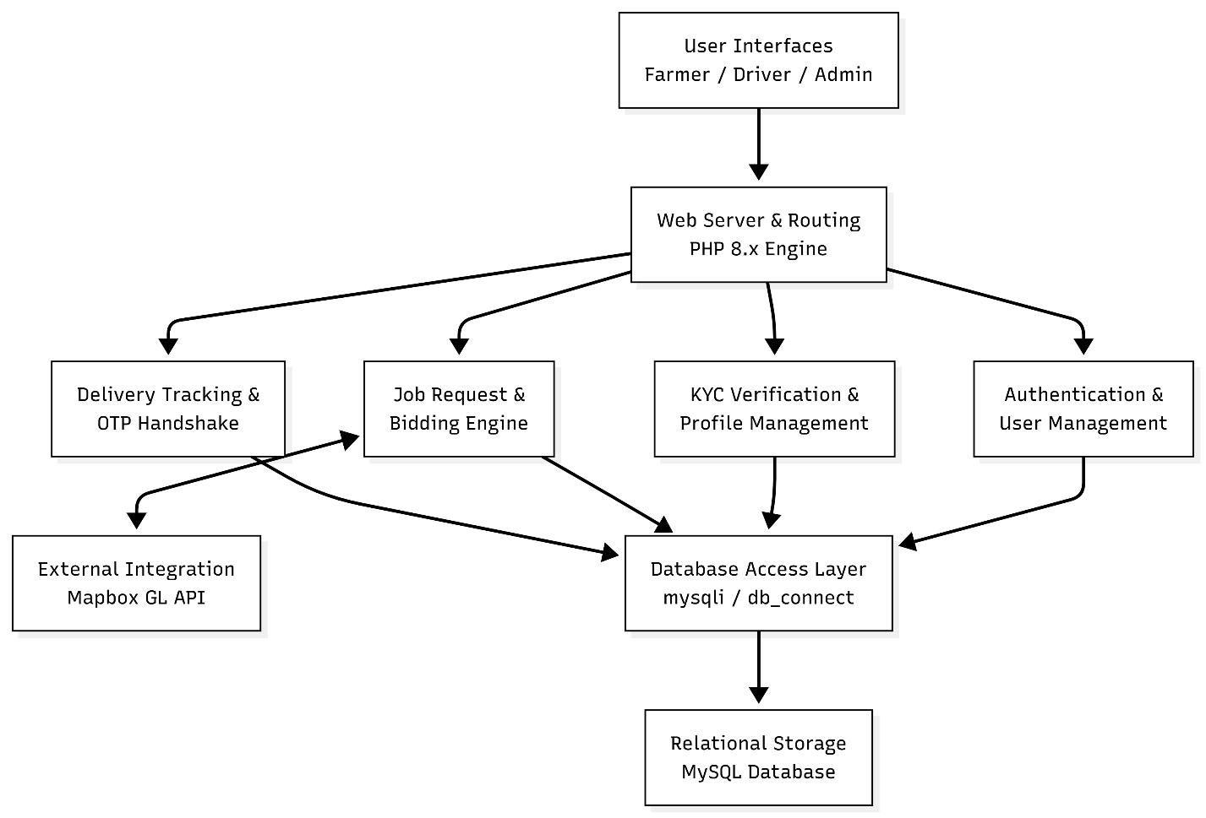

3.6.2 Context Diagram
The context diagram shows the interaction between the AgriMove System and its external entities. The main external entities include:
- Farmers: Submit crop details and request transport services.
- Transporters: Submit compliance documents, place bids on jobs, and provide transportation services.
- Platform Administrator: Manages the system, audits platform logistics, and approves/rejects driver verifications.
- Mapbox API (External System): Receives geocoding requests from the platform and returns precise route data and distance calculations (in KM) to help structure pricing.
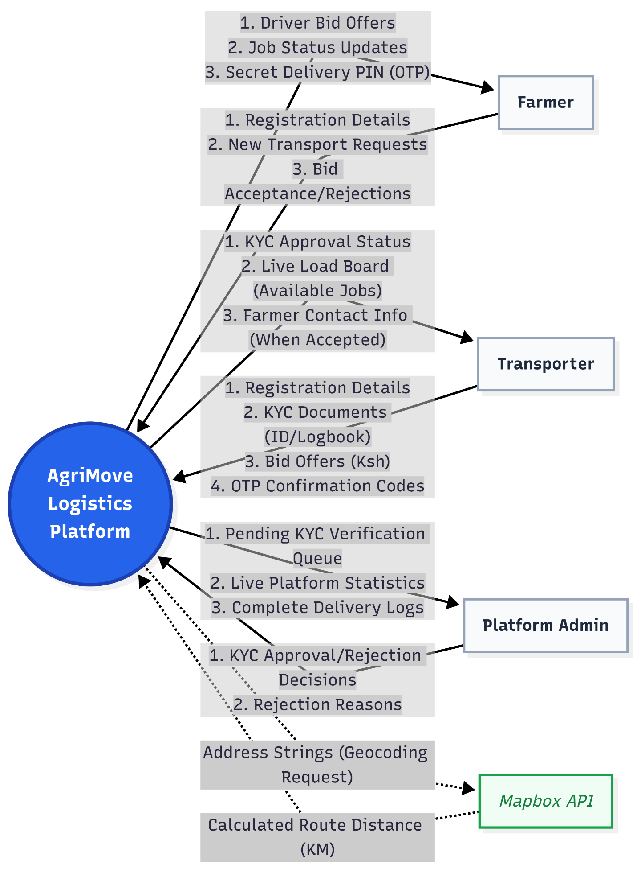
3.6.3 Use Case Diagram
The use case diagram illustrates how different authenticated roles interact with the system's features.
Farmer Use Cases
- Register and Login to the system
- Create map-based Transport Requests
- View incoming financial bids from verified transporters
- Accept a transporter's bid
- Provide the generated secure Delivery PIN (OTP) to the driver upon arrival
Transporter Use Cases
- Register and Login to the system
- Submit KYC Documents (ID/Logbook) to unlock the profile
- View the Live Load Board (Available Jobs)
- Submit competitive bids on open farm loads
- Start transit and track active deliveries
- Input the Farmer's secret PIN to confirm physical delivery
Administrator Use Cases
- Securely Login to the Command Center
- Review pending Transporter KYC documents side-by-side
- Approve or Reject (with reason) driver verifications
- Monitor overall system activity and completed delivery statistics
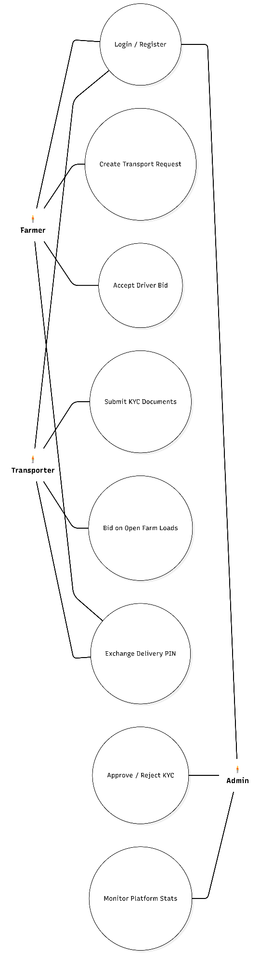
3.6.4 Data Flow Diagram (DFD)
The Data Flow Diagram illustrates how information moves through the AgriMove system, from external entities to internal data stores.
Major processes include:
- User Registration & Authentication (1.0): Validating credentials and creating user sessions.
- KYC Verification Process (2.0): Moving driver documents into the transporter_profiles table, locking them, and updating the status based on Admin input.
- Job Management & Bidding (3.0): Storing farmer requests in the transport_requests table, displaying them on the Load Board, and updating records when a driver places a bid and a farmer accepts it.
- Delivery Tracking & Fulfillment (4.0): The process of generating an OTP in the database, displaying it to the farmer, and verifying the driver's input to mark the job as 'Delivered'.
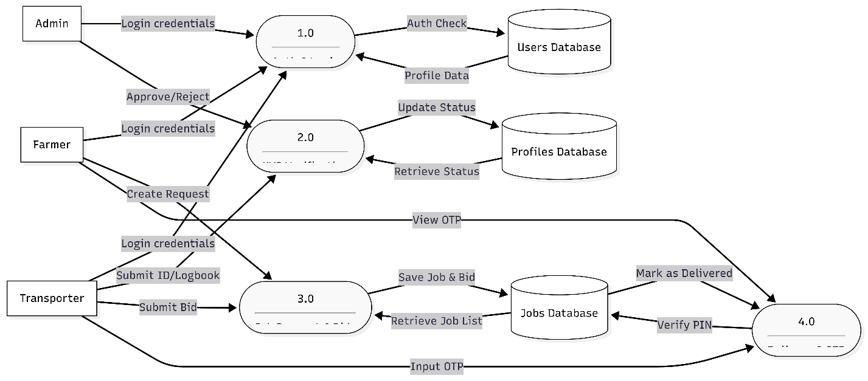
3.6.5 Sequence Diagram
The sequence diagram details the specific chronological order of operations for AgriMove's core loop: The Job Bidding and OTP Delivery Handshake.
The process follows these exact chronological steps:
- The Farmer logs in and submits a transport request with pickup/delivery coordinates.
- The system calculates the distance via Mapbox and records the request as 'Pending' in the database.
- A Verified Transporter views the load board, clicks the job, and submits a monetary bid.
- The Farmer reviews their dashboard, evaluates the bids, and clicks 'Accept' on their preferred driver.
- The system updates the job status to 'Accepted' and generates a secure 4-digit OTP.
- The Transporter begins the journey and updates the status to 'In Transit'.
- Upon physical arrival, the Farmer reads the secret OTP from their dashboard and gives it to the Transporter.
- The Transporter enters the OTP into the system.
- The system validates the code against the database. Upon a successful match, the system permanently marks the job as 'Delivered' and increments the platform's completed statistics.

CHAPTER 4
4.0 System Development and Deployment
This chapter documents the coding, testing, and deployment stages of the AgriMove Farmers Transport System project, marking the beginning of the solution domain.
4.1 System Description and Deployment
4.1.1 Front-end Development The front-end development focused on creating a user-friendly, responsive, and intuitive interface for the system. I utilized HTML5, Tailwind CSS, and JavaScript (including Mapbox GL JS) to create the interactive user interfaces, map routing functionalities, and role-specific dashboards.
4.1.2 User Interface Design The user interface (UI) was designed with the following objectives:
- Clarity: Clear and concise labeling for all elements, utilizing distinct color coding (e.g., Green for Farmers, Blue for Transporters) to establish visual hierarchy.
- Consistency: Consistent use of modern typography (Inter font family), soft shadows, and rounded layouts throughout the system.
- Efficiency: Streamlined workflows to minimize user effort, such as automated distance calculation and one-click bid acceptance.
- Responsiveness: Adaptability to various screen sizes for optimal viewing on mobile devices, tablets, and desktop computers.
4.1.3 Interface Modules
4.1.3.1 User Authentication Module
- Purpose: Manages user login, registration, and role-based access control.
- Features:
  - Role-specific registration (Farmer vs. Transporter).
  - Secure password hashing and authentication.
  - Role-based dashboard routing (Admin, Farmer, Transporter).
  - Input validation for Kenyan phone numbers and email formats.
4.1.3.2 Farmer Dashboard
- Purpose: Provides farmers with a centralized hub to manage their agricultural logistics.
- Features:
  - Interactive map-based transport request creation.
  - View active requests and incoming bids from drivers.
  - Accept or decline transporter bids.
  - Generate and view the secure 4-digit Delivery PIN (OTP) for active transits.
4.1.3.3 Transporter Dashboard & Load Board
- Purpose: Enables verified drivers to find farm loads and manage their operations.
- Features:
  - Submit and manage KYC Verification documents (ID and Logbook).
  - Live Load Board to browse pending farm requests.
  - Submit financial bids (Ksh) based on cargo weight and route distance.
  - OTP input portal to securely finalize and confirm deliveries.
4.1.3.4 Admin Command Center
- Purpose: Allows the platform administrator to manage security, users, and overall logistics.
- Features:
  - Manage and monitor platform statistics (total users, active trips, completed deliveries).
  - Review pending KYC submissions side-by-side (Old vs. New details).
  - Approve or reject Transporter profiles with required reasoning.
  - Monitor live platform activity logs.
4.1.3.5 Job & Bidding Engine (Core Logic)
- Purpose: Tracks the lifecycle of a transport job from creation to fulfillment.
- Features:
  - Assigns real-time statuses: Pending, Accepted, In Transit, Delivered.
  - Links produce data, farmer details, and transporter profiles dynamically.
  - Locks driver profiles during the verification stage to prevent fraudulent data changes.

REFERENCES
- Boehm, B. (1988). A Spiral Model of Software Development and Enhancement. ACM SIGSOFT.
- Cockburn, A. (2006). Agile Software Development: The Cooperative Game. Addison-Wesley.
- Cohn, M. (2005). Agile Estimating and Planning. Pearson Education.
- Fowler, M. (2006). Continuous Integration. Martin Fowler.
- Hass, K. B. (2007). The Blending of Traditional and Agile Project Management. PMI Global Congress Proceedings.
- Pressman, R. S. (2014). Software Engineering: A Practitioner's Approach. McGraw-Hill.
- Williams, L., & Cockburn, A. (2003). Agile Software Development: It's about Feedback and Change. IEEE Computer, 36(6), 39-43.

APPENDIX
Definitions
- Farmers Transport System: A digital logistics platform (AgriMove) that facilitates the connection, negotiation, and secure fulfillment of agricultural transport between farmers and independent drivers.
- Transport Request: A formal job posting created by a farmer detailing the crop type, total weight, pickup location, and delivery destination.
- KYC (Know Your Customer): The verification process where transporters submit their National ID and Driving License/Logbook to ensure platform safety.
- OTP (One-Time Password): A secure 4-digit PIN generated by the system and given to the farmer to verify successful physical delivery.
Abbreviations
- KYC: Know Your Customer
- OTP: One-Time Password
- UI: User Interface
- DB: Database
- API: Application Programming Interface
Roles and Responsibilities
- Farmer
  - Create transport requests.
  - Review incoming bids and select a transporter.
  - Provide the secret Delivery PIN to the transporter upon successful arrival.
- Transporter
  - Submit required KYC documents for verification.
  - Review the Load Board and place competitive bids on jobs.
  - Transport the goods and input the Farmer's PIN to complete the job.
- Administrator
  - Review and finalize Transporter KYC verifications.
  - Ensure strict adherence to platform security protocols.
  - Monitor platform logistics and user activity.
Process Flow (The Delivery Lifecycle)
- Login: Users (Farmers and Transporters) log into the system using their secure credentials.
- Request Submission: The Farmer utilizes the map interface to submit a new transport request.
- Load Board Broadcast: The system records the request and displays it to all verified Transporters on the Live Load Board.
- Bidding Phase: Transporters review the job details (distance, weight) and submit a monetary bid.
- Acceptance: The Farmer reviews the bids and accepts their preferred Transporter. The system generates the Delivery PIN.
- Transit: The Transporter moves the produce and updates the system status upon arrival.
- OTP Handshake (Completion): The Transporter inputs the Farmer's secret PIN into the system. The system verifies the PIN and marks the job as officially 'Delivered'.
System Components
- User Interface (UI): The front-end part of the system (Tailwind CSS/HTML) where users interact.
- Database (DB): The backend relational component (MySQL) that stores all data related to users, profiles, and transport requests.
- Routing Service: The Mapbox API integration that calculates distance logic for jobs.
- Authentication Service: The PHP logic that manages user login, session security, and role-based access.

